[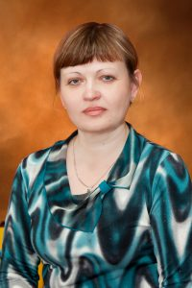](http://cdou2.ru/wp-content/uploads/2016/06/%D0%91%D0%BE%D1%80%D0%BE%D0%B2%D0%BA%D0%BE%D0%B2%D0%B0-%D0%9D.%D0%9B..jpg)

Боровкова Наталья Леонидовна